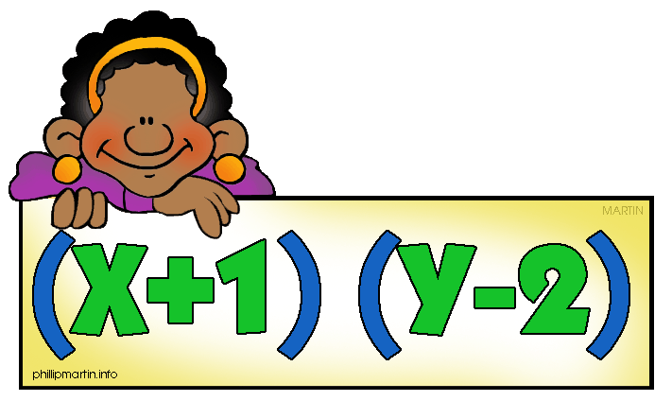

**Algebra II**

**Course Syllabus & Policy Sheet**

[**GamblCh@boe.richmond.k12.ga.us**](mailto:GamblCh@boe.richmond.k12.ga.us)

**706-840-3394**

**Course Description:**

This course is designed to build on algebraic and geometric concepts.  It develops advanced algebra skills such as systems of equations, advanced polynomials, imaginary and complex numbers, quadratics, and concepts and includes the study of trigonometric functions.  It also introduces matrices and their properties.  The content of this course are important for students’ success on both the ACT and college mathematics entrance exams.  Students who complete Algebra II should take Pre-Calculus next.

**Instructional Philosophy:**

My Instruction philosophy is to teach students well and let them lead the way. Every classroom presents a unique community of learners that varies not only in abilities, but also in learning styles. My role as a teacher is to give students the tools with which to cultivate their own gardens of knowledge. To accomplish this goal, I will teach to the needs of each child so that all learners can feel capable and successful. I will present curriculum that involves the interests of the students and makes learning relevant to life. I will incorporate themes, integrate unites, projects, group work, individual work and hands-on learning to make the students active learners. Finally, I will tie learning into the world community to help students become caring and active members of society.

**Major Course Goals**: The major course goal is for students to learn essential knowledge and skills about Functions, Algebra, Geometry, Statistics and Probability, Algebra in Context, and Coordinate Geometry. Once mastered, these goals will give a student the ability to use reasoning and thinking skills to learn and understand other curriculum objectives.

**Major Course Projects & Instructional Activities**: The major course projects and instructional activities include tasks, homework, quizzes, tests, and projects. The assignments and projects will ask students to read and demonstrate an understanding of what was read, written and given in oral presentations. The assignments and projects will ask students to apply what they are learning to real world problems and situations.

**Course Assessment Plan**: The course will follow the following grade distribution: Homework/classwork is 10%, Lab is 30%, quizzes are 20%, and tests are 40% of the students’ 9-week grade. The grading scale is **A** 90-100%, **B** 80-89%, **C** 70-75%, **D** 74% - 70%, **F** Below 70% but this grading scale/distribution is subject to change per the Richmond County Math Department. There will be benchmark tests given throughout the year and a final comprehensive exam for all students.

**Classroom Expectations**: Students will respect each other and honor private think time. Students should be in their seats and stay seated by the time the late bell sounds, take out the previous night’s assignment to be checked. Students are to come to class prepared. Students should use the restroom before coming to class. Students will follow the policies and regulations as outlined in the student handbook, including homework policies.

**Supplies and Materials Needed**: Students must maintain a notebook which will be graded as a quiz grade throughout each nine weeks. It is their choice for it to be a folder with paper and pockets, binder with paper and pockets or spiral notebook with pockets. It must be dedicated to math. Students will need to bring a writing utensil (other than red ink), pencils, and a scientific calculator every day to class. Carnegie Student textbooks are required for class each day.  I have a class set of graphing calculators, but these cannot go home.

**HELP AVAILABILITY**: TUTORING (Available Upon Request)**.**

**Makeup Work/Recovery Policy**

“HANDBOOK “All missed work and assessments are the **responsibility of the student when they are absent from school.** The teacher is not to be asked at the beginning or ending of class on the day of return to ask what was missed. An assignment folder detailing worksheets and other forms of assessments will be available for student when assignments are missed. A student who is absent on the class day before a regularly scheduled assessment will be responsible for completing the assignment on the regularly scheduled day and time. Students who have been absent more than two consecutive days (including the assessment day) will be given five (5) school days to make up the assessment and/or other assignments. This does not include major projects, research papers, etc., where the deadline has been posted in advance. The teacher has the discretion to grant time periods to make up work if there are extenuating circumstances. Class work and assignments can be found online.

**Discipline Policy/Procedures**

The discipline policy of the Richmond County School System (Code of Conduct) and T.W. Josey High School (Student Handbook) will be obeyed. The first violation will be recorded and the student will be advised on how to correct the situation. The second offense will be documented, the student will be assigned detention, and a parent or guardian will be contacted. The third violation will be referred to the administration. Refusal to follow directions and serious violations will result in an immediate referral to the administration. Students who receive no infractions will be identified and rewarded monthly with a free homework pass.

**Cheating**

**Cheating** is talking or passing papers between students during a test, or giving and/or receiving answers. Cheating will ***NOT*** be tolerated! The Richmond County Board of education policy on plagiarism and cheating will be followed.

**Class Rules**

1. Please be on time in your assigned seat and ready to work immediately upon entering the classroom.
2. Be prepared with all the supplies and designated work.
3. Raise your hand to get out of your seat or to speak and treat everyone with respect.
4. Please take all your books or other materials with you when you leave my class. Anything found will be turned in to the lost and found or the media center.
5. No eating, drinking or gum chewing.
6. There will be **NO** sleeping or laying down of head in class.
7. There will **NOT** be any **OBSCENE** language used in this class.
8. Get water, use the restroom, and sharpen pencils before class.
9. Cellphone usage will **NOT** be allowed in class.

***\*\*Return this sheet to the teacher immediately\*\****

***My student and I have read the entire syllabus and understand the expectations of the class. In addition, it is clear that the above supply list is mandatory for all students. Should you need assistance obtaining any of these supplies, please contact me. Otherwise, it is assumed that each student will come to class daily with all of the aforementioned supplies.***

***\*\*It is further understood that failure to complete assignments and independent practice will result in poor performance and lack of success in this class and further study in mathematics.***

Student Signature:_____________________________________________________________

Parent Signature:______________________________________________________________

Date _________________________________________________

Student **Full** Name (Print Legibly): __________________________________________________________

Parent Name(s) (Print Legibly): _________________________________________________________

**\*\*Parent Contact Information: (please print *legibly* below)**

__________________E-mail: **________________________________________ □ Email Me!**

Who’s Address?

(Work or Home) Phone: ______________________ _______________Cell):______________

Circle One Who’s Number?

__________________E-mail: **________________________________________ □ Email Me!**

Who’s Address?

(Work or Home) Phone: ______________________ _______________Cell): _____________

Circle One Who’s Number?